**Web Tours Performance Testing with JMeter**

**About :**

JMeter project on WebTours app: login, flight booking, passenger details & sign-off. Features data-driven testing via CSV (5 users), regex correlation, assertions, transaction controllers, HTTP cookie manager, listeners, with CSV results & HTML report generation for performance analysis.

**Listeners –**

Listeners in JMeter capture and display test results in various formats, essential for analysing the performance and correctness of test scenarios.

View Results Tree –

This listener provides detailed information for each sample request during the test execution. It shows the request and response data, useful for debugging failures or unexpected behaviour in the test plan.

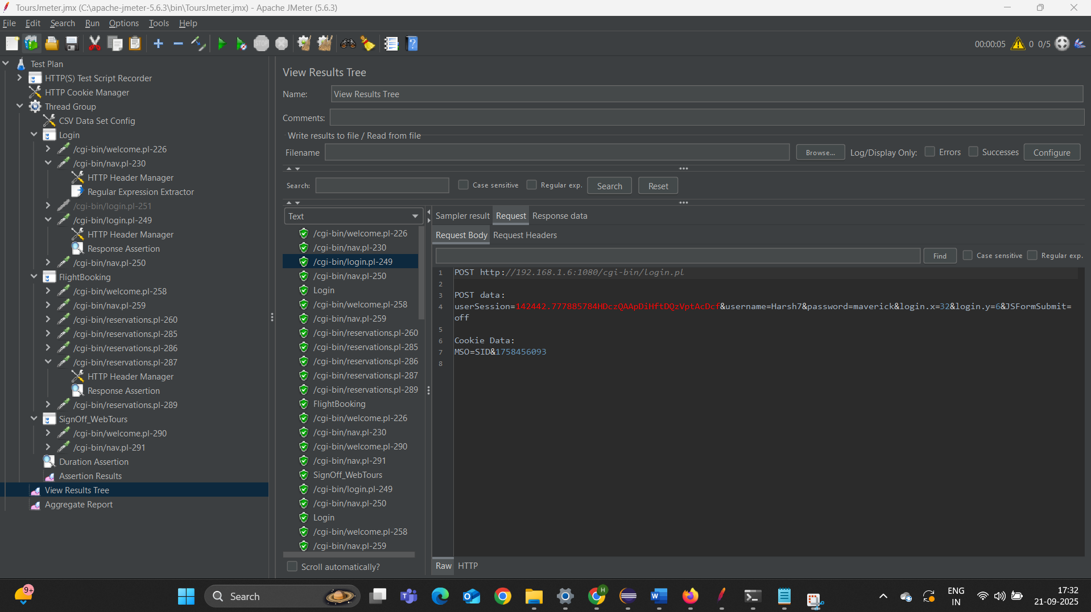

Assertion results –

Displays information on assertions applied to requests, highlighting which assertions passed or failed, and providing failure messages for troubleshooting.

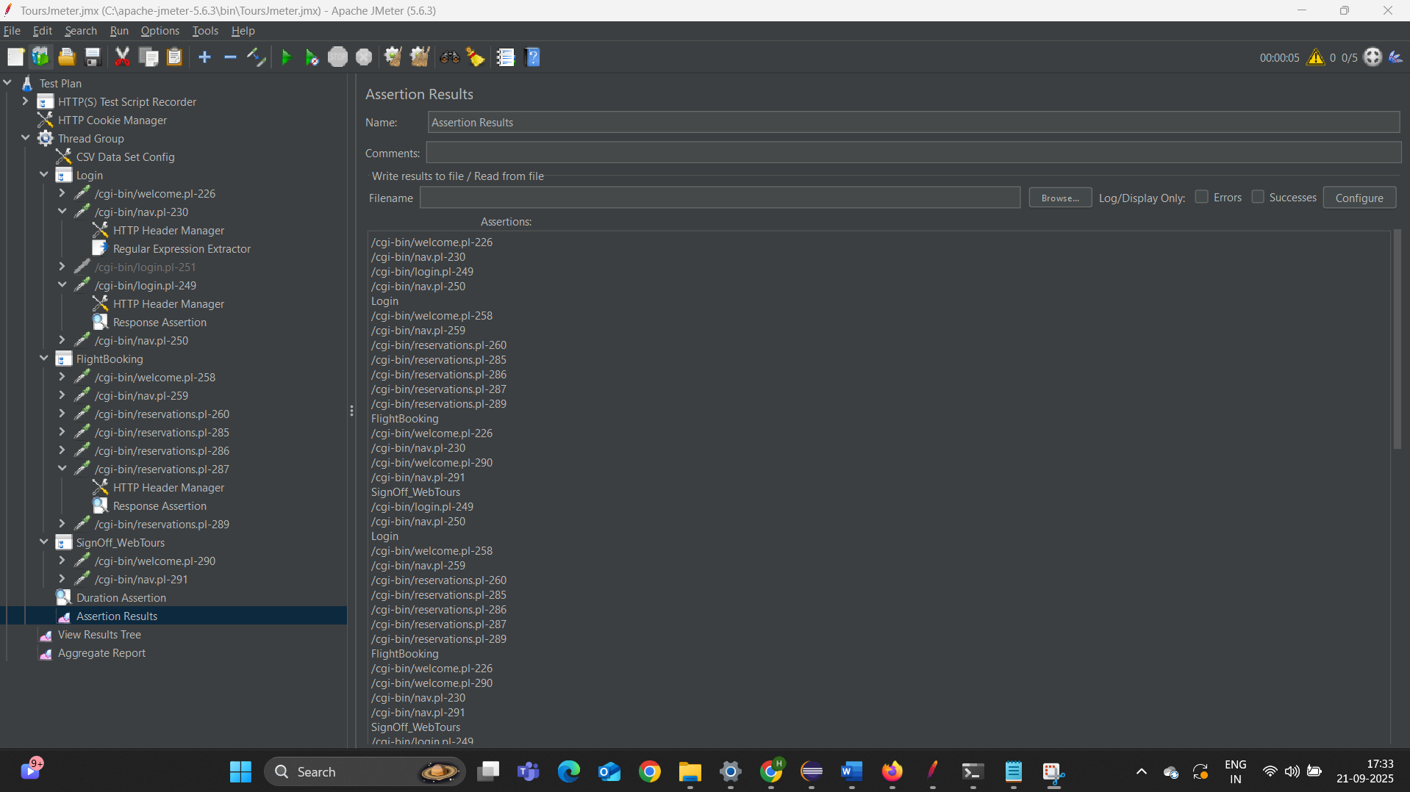

Aggregate report –

Summarizes key performance metrics such as average response time, throughput, error percentage, and standard deviation across all requests. This report gives a comprehensive overview of the system performance under test.

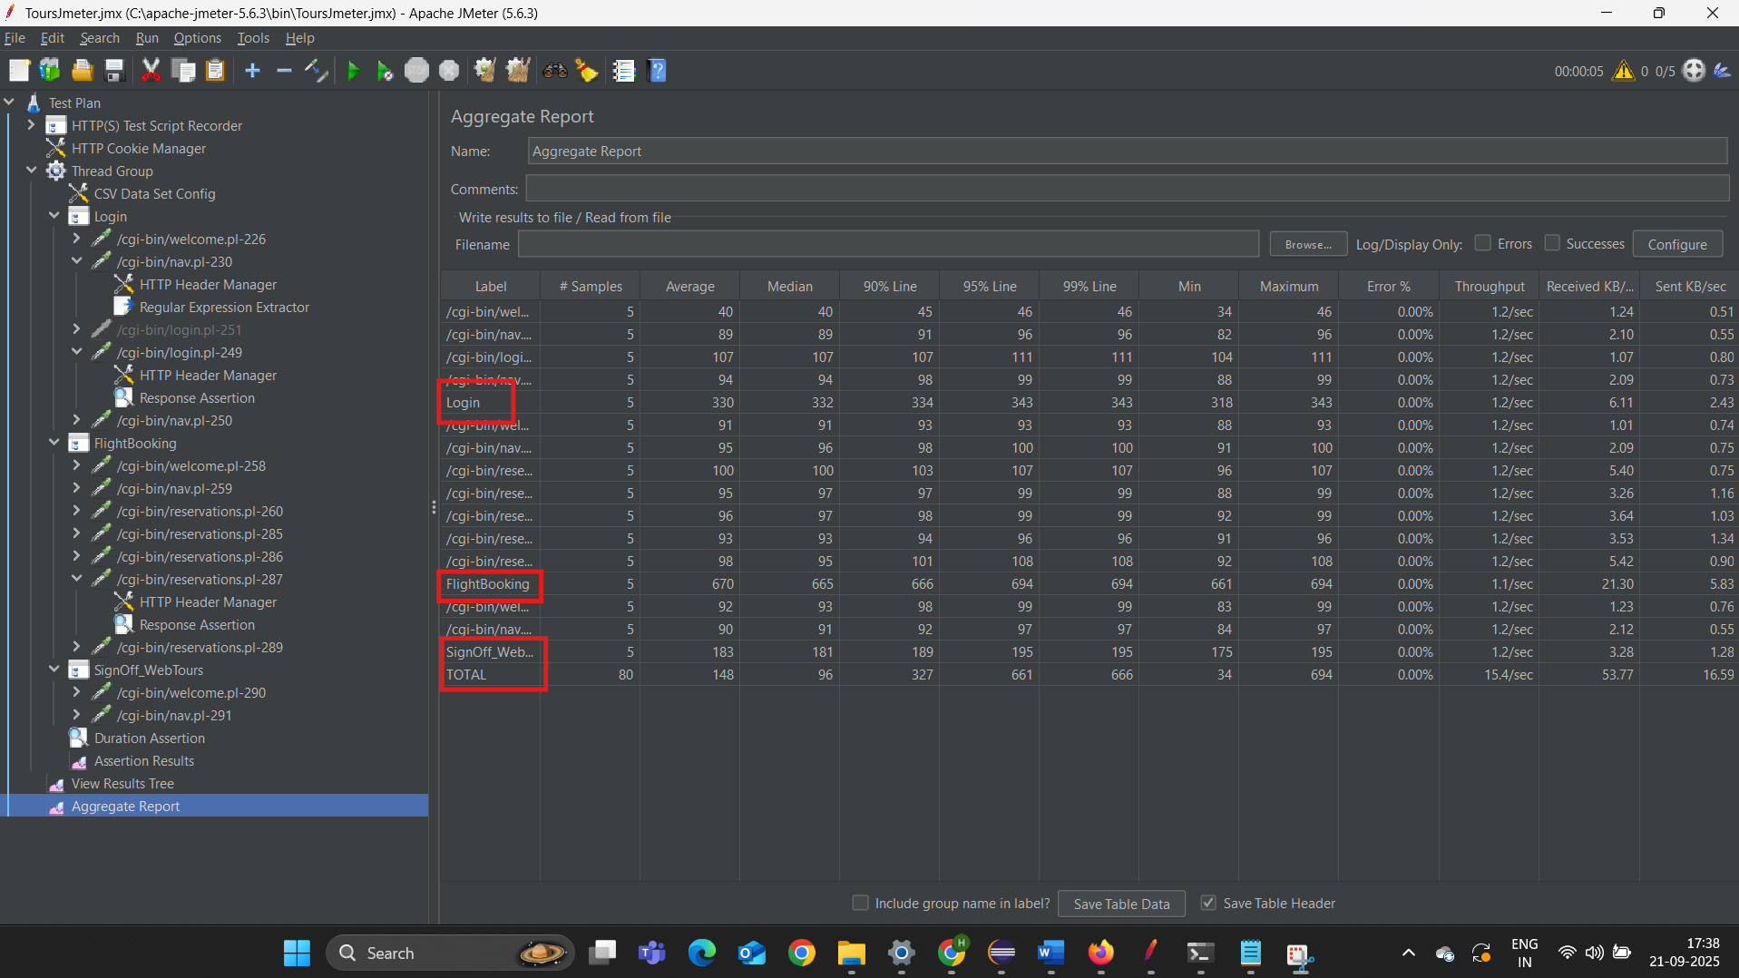

Duration Assertion –

A specific assertion validating that responses are received within a set duration, helping to confirm performance SLA compliance.

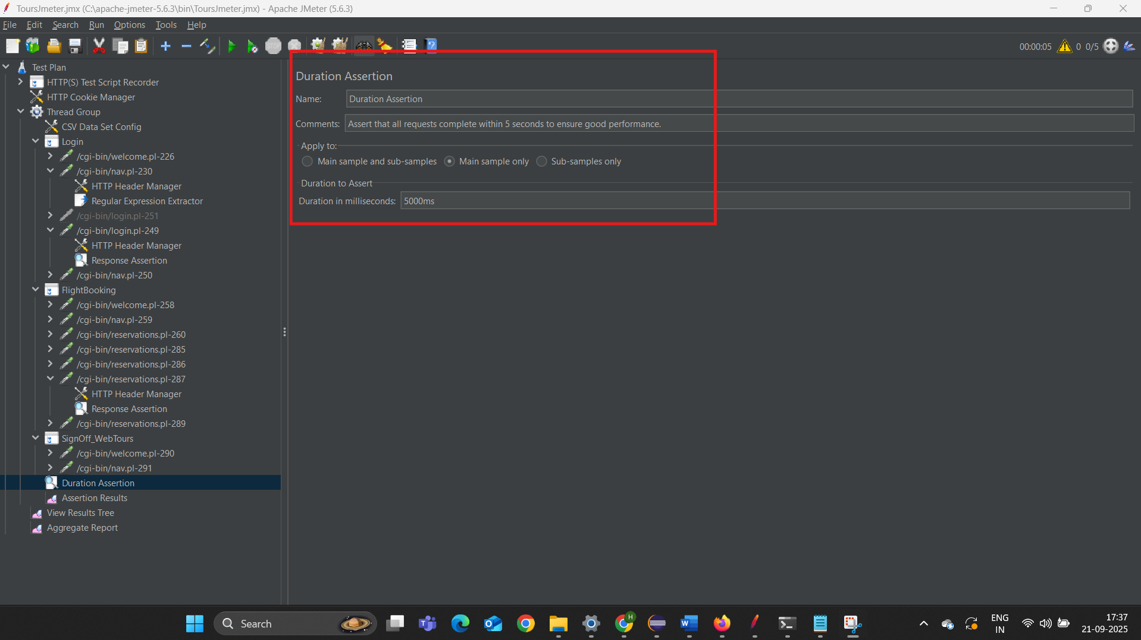

Response Assertion –

Confirms the content of responses based on various checks like presence of strings or patterns, ensuring the correctness of the returned data.

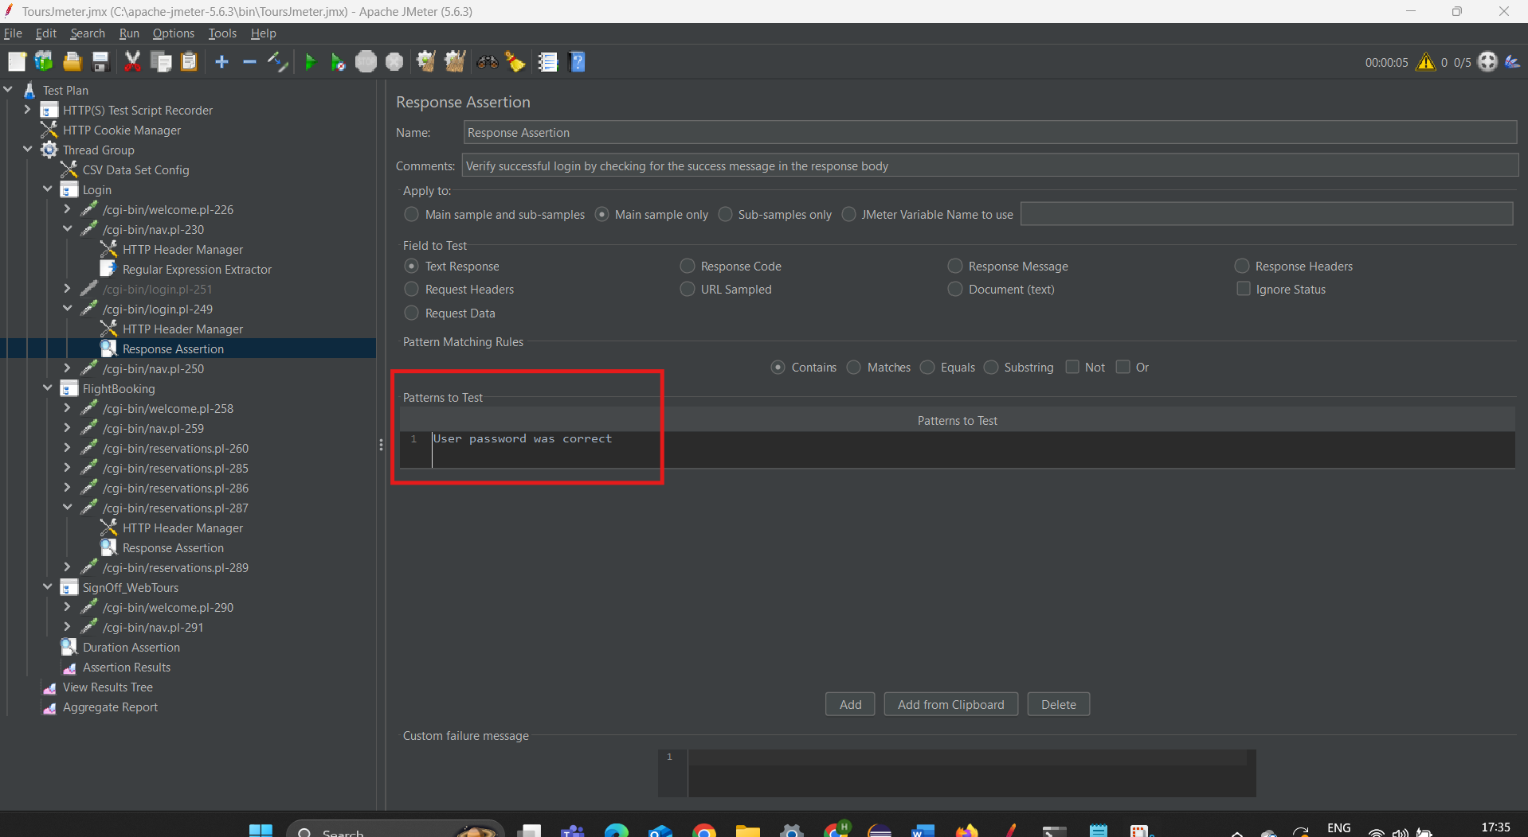

**Regular expression extractor –**

These components extract dynamic data from server responses to be reused in subsequent requests, enabling realistic and stateful test scenarios.

**Showcasing Correlation -**

Extracting values from the previous response using a Regular Expression

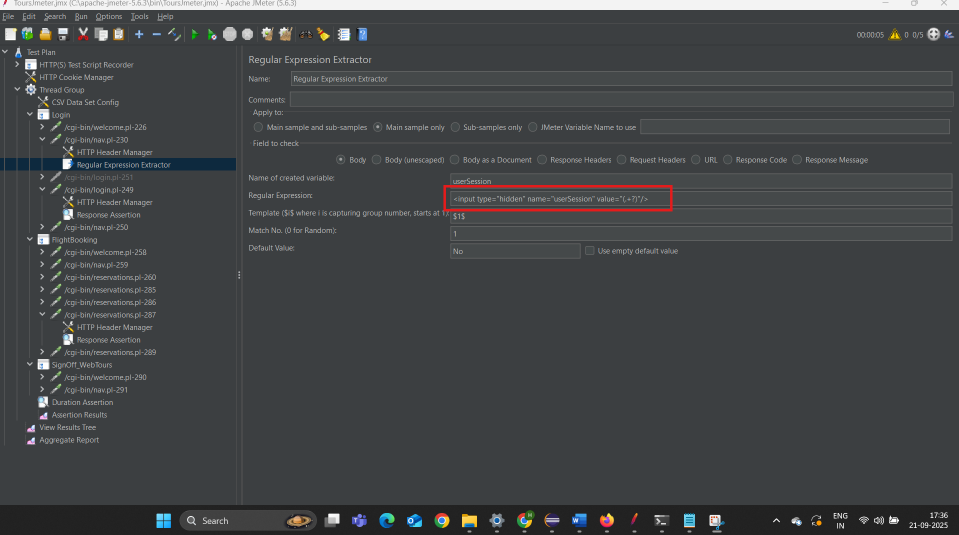

Passing the “userSession” variable to the next request, allowing the value from the previous response to be used in the subsequent request.

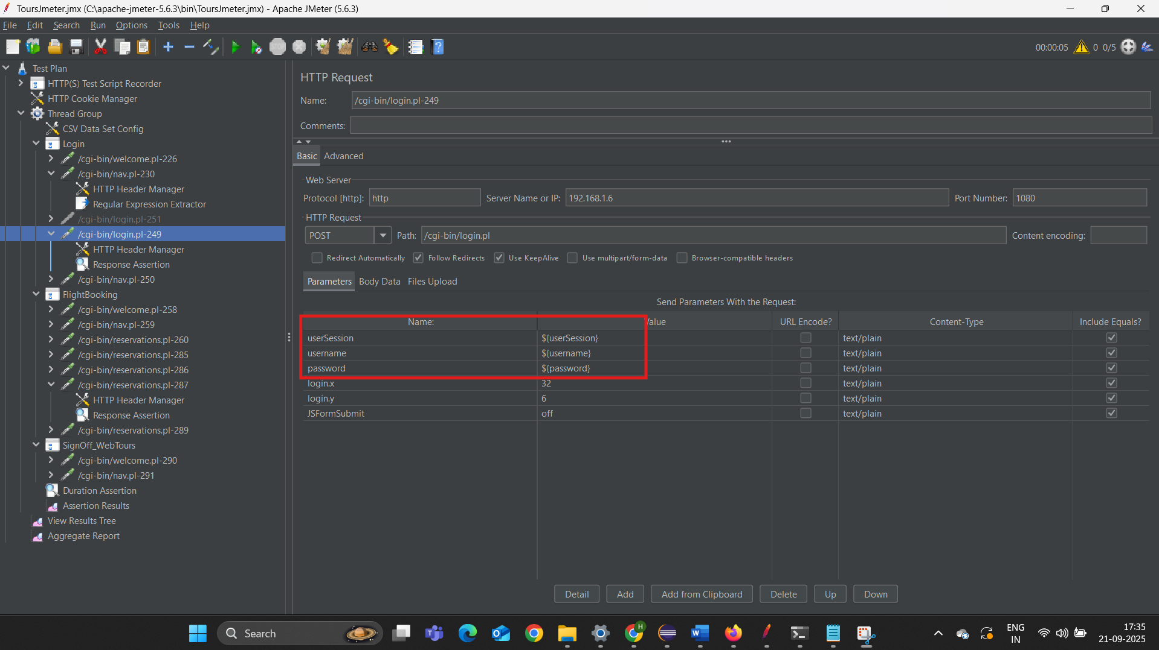

Extracted via Regular Expression, the userSession ID is forwarded to the request body of the subsequent sample.

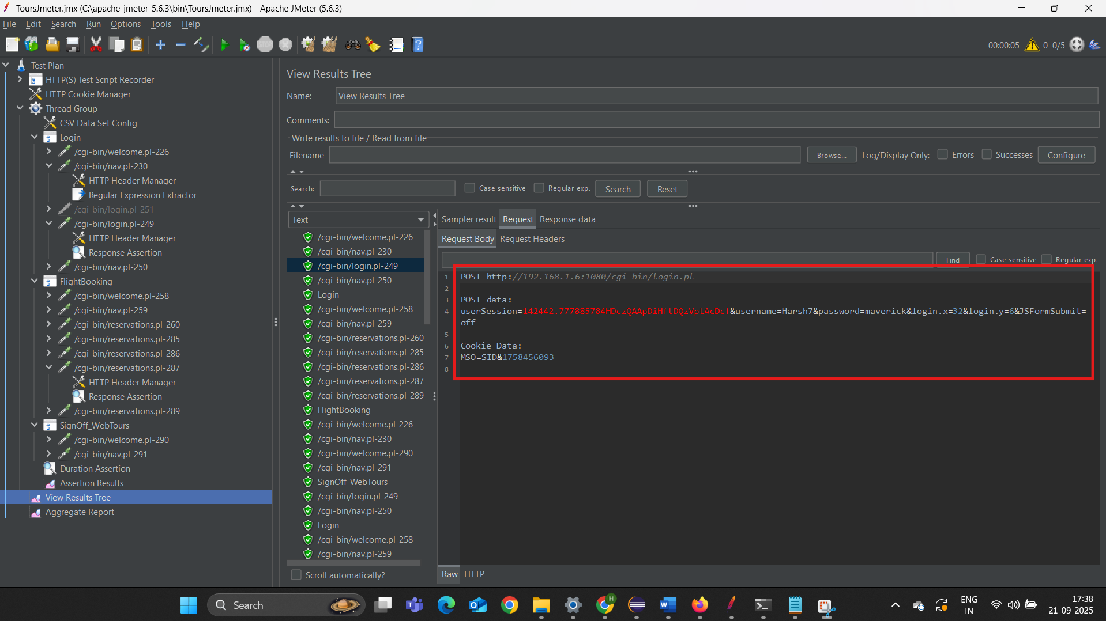

**CSV Data Set Config. –**

Configuring CSV file data input for parameterization of requests, allowing multiple data-driven iterations during the test run.

Importing a CSV file from the local system and using the values it contains as input variables.

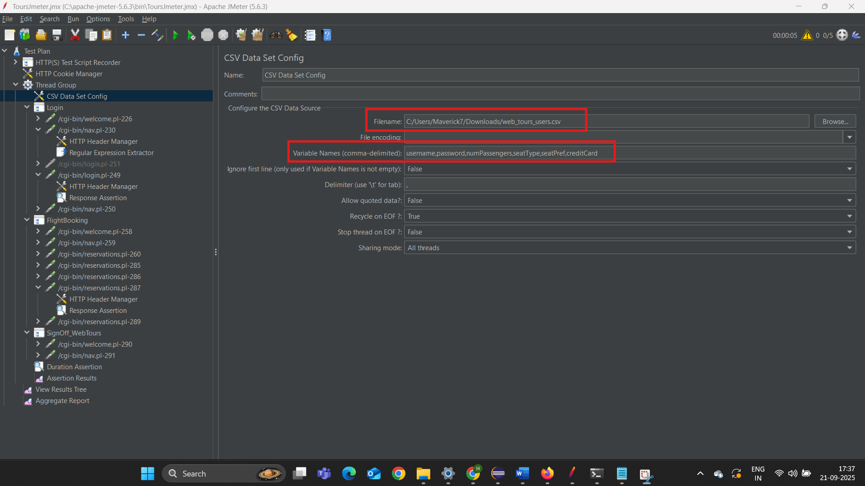

Using CSV Config and CSV files to pass parameters such as credit card, number of passengers, and seat type as variables

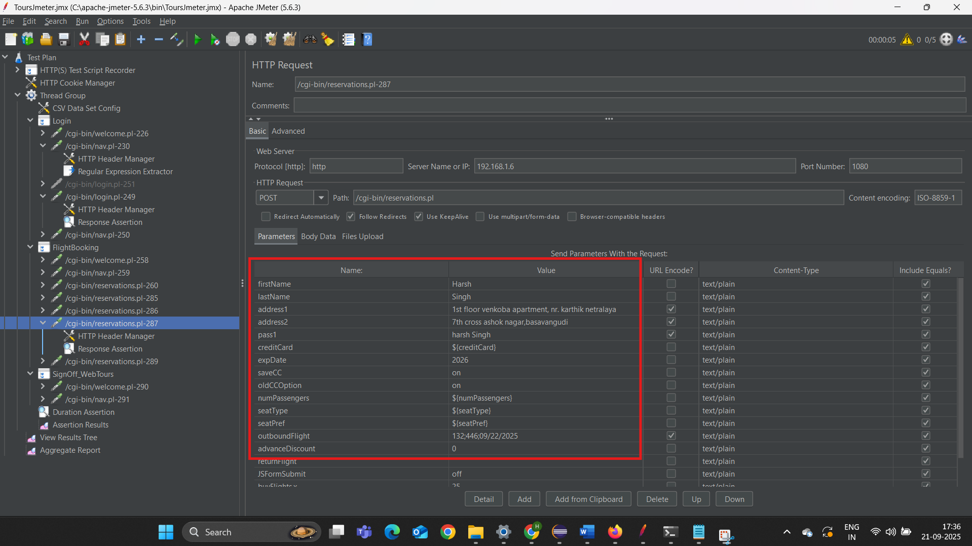

**HTML Reports –**

Visual representation of test results in graphical format with detailed statistics and trend insights, enhancing result interpretation and communication.

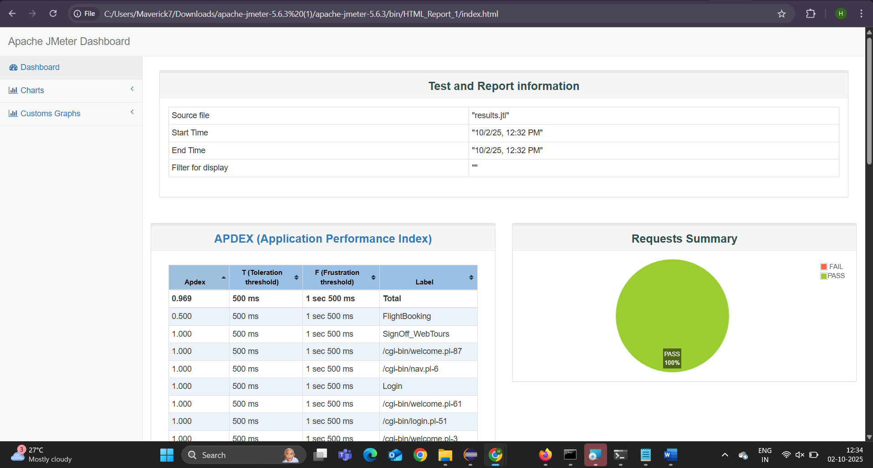

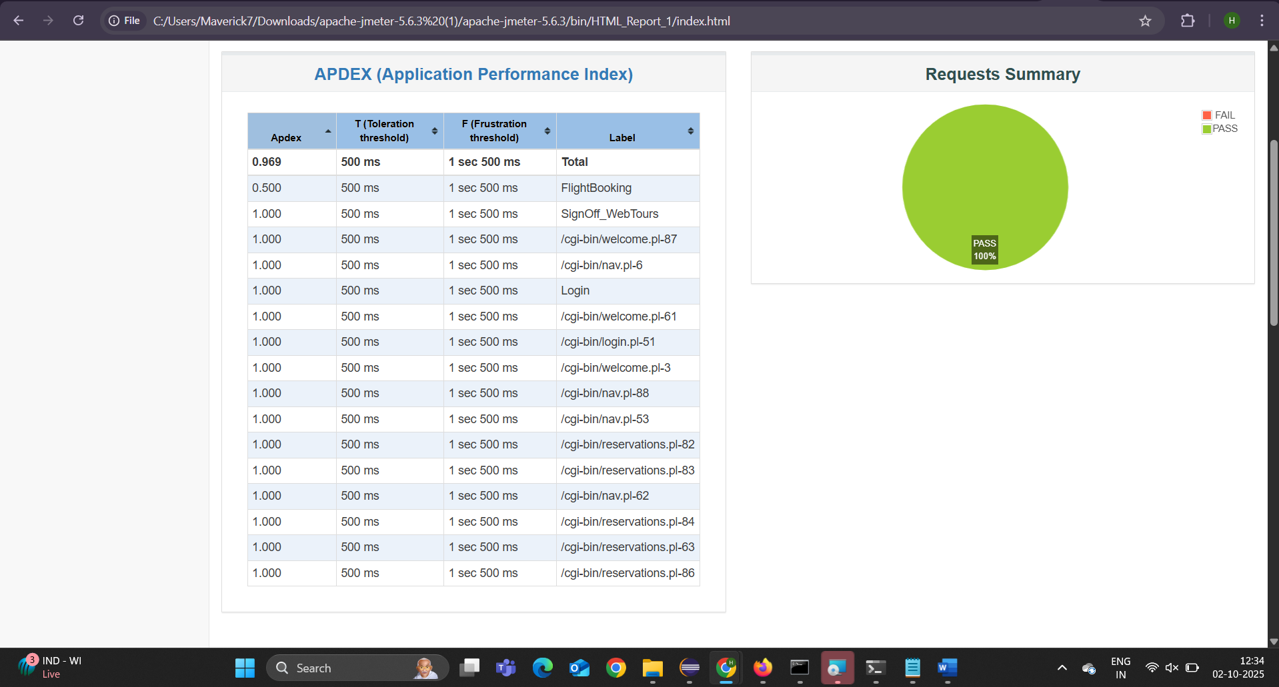

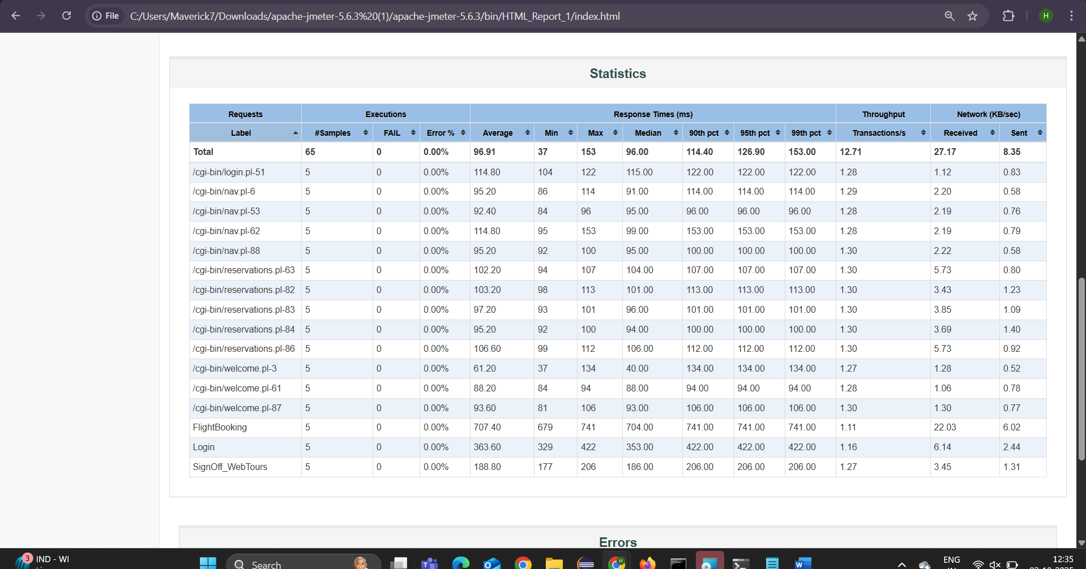

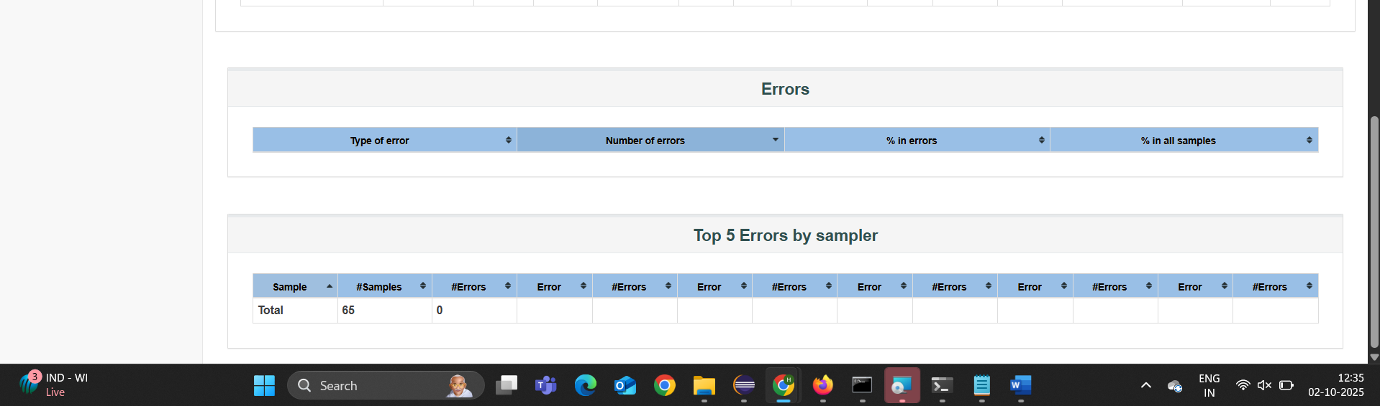

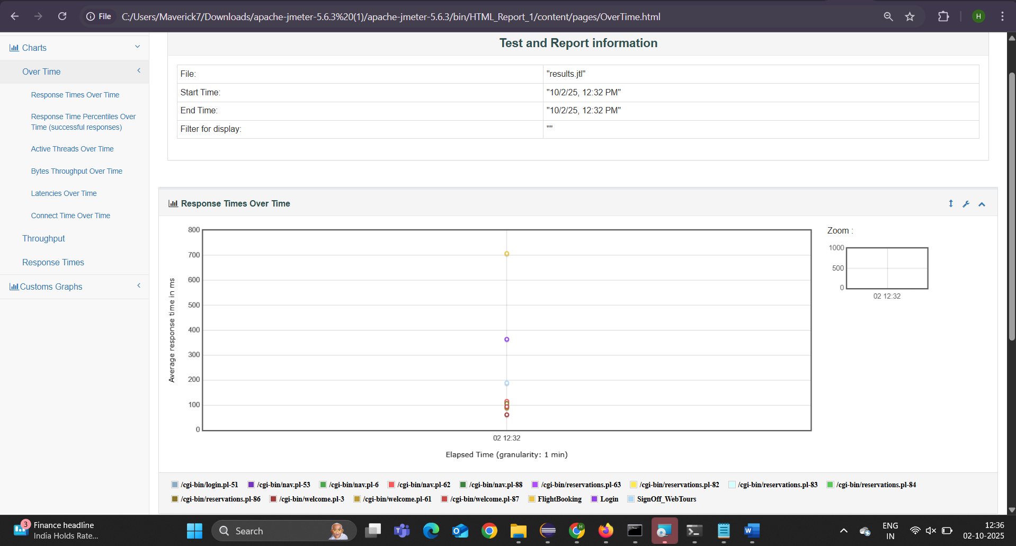

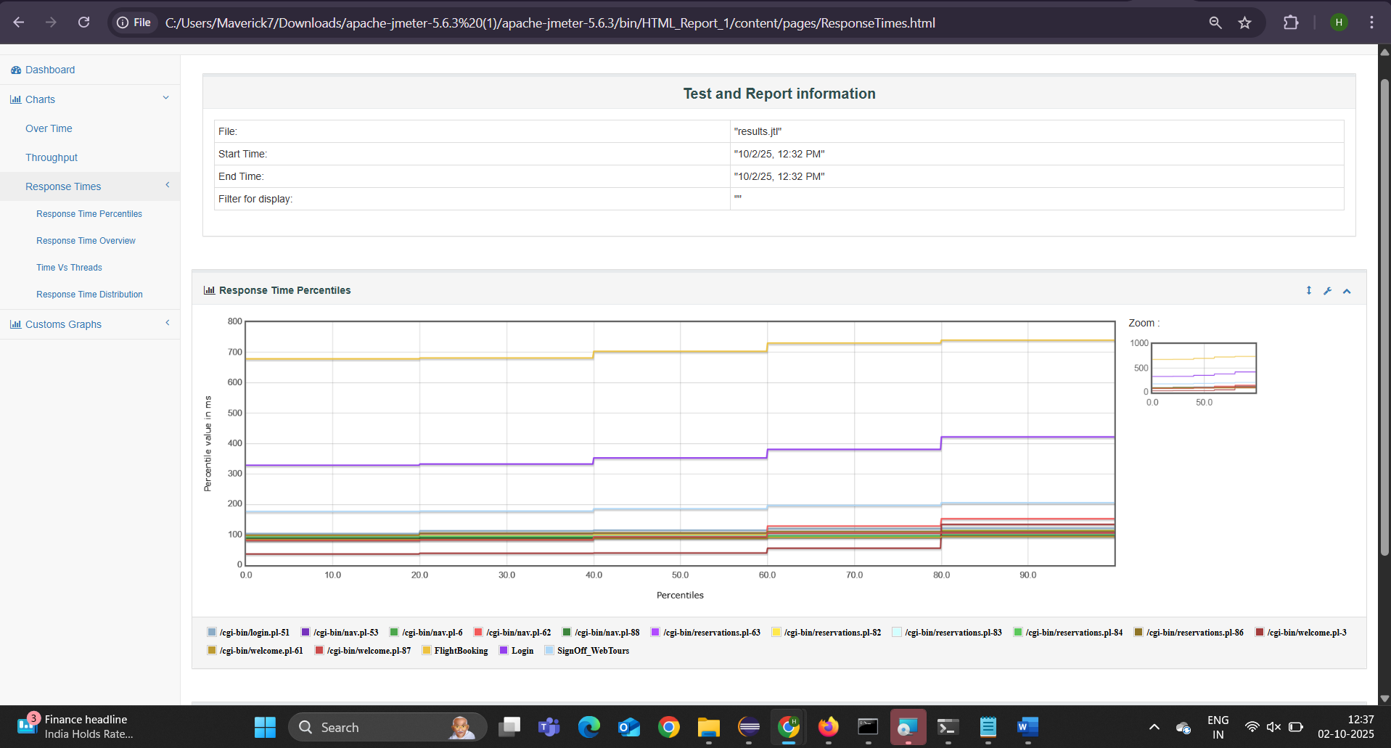

**CSV Results –**

This section shows the raw test data exported in CSV format, capturing each request's detailed metrics such as response times, status, and thread information. The CSV results enable deeper analysis and custom processing outside JMeter’s built-in reporting tools.

